Snort IDS Lab — Step‑by‑Step (Rhombix Technologies)
A complete, do‑this‑then‑that guide to set up a 3‑VM lab, simulate attacks, write custom Snort rules, and analyze alerts.

0) Prerequisites
- Host machine: 8 GB RAM (minimum), 40+ GB free storage.
- Hypervisor: VirtualBox (recommended). VMware Workstation/Player also works.
- ISOs:
  - Kali Linux (attacker)
  - Ubuntu Server/Desktop LTS (victim + sensor)
- Time: ~2–3 hours for first run.

1) Lab Topology & IP Plan
[Attacker: Kali] 192.168.56.10/24
[Victim: Ubuntu] 192.168.56.20/24
[Sensor: Ubuntu + Snort] 192.168.56.30/24
│
[VirtualBox Host‑Only Switch] 192.168.56.0/24
Gateway/DNS: none required for this isolated lab.

2) Create the Virtual Network (VirtualBox)
- Open VirtualBox » Tools » Network » Host‑only Networks.
- Click Create → select the new host‑only network (e.g., vboxnet0).
- Configure:
  - IPv4: 192.168.56.1
  - Mask: 255.255.255.0
  - DHCP: Off (we will use static IPs)
- In each VM’s Network settings:
  - Adapter 1: Host‑only Adapter → choose vboxnet0.
  - Promiscuous Mode: Allow All (important so the sensor sees all traffic).
  - Cable Connected: checked.
VMware tip: Put all VMs on the same custom host‑only network (e.g., VMnet2), enable promiscuous mode in the Virtual Network Editor, and set it to Allow All.

3) Create the VMs
Create three VMs with the following minimal specs: - Kali (Attacker): 2 GB RAM, 2 vCPU, 20 GB disk - Ubuntu (Victim): 2 GB RAM, 1–2 vCPU, 20 GB disk - Ubuntu (Sensor): 2–4 GB RAM, 2 vCPU, 20 GB disk
Install OS normally from ISO.

4) Set Static IPs

4.1 Ubuntu (Victim & Sensor) — Netplan
Find interface name:
ip link show
Create/edit /etc/netplan/01-hostonly.yaml (adjust interface name):
network:
version: 2
ethernets:
enp0s3:
addresses: [192.168.56.20/24] # Victim use .20; Sensor use .30
dhcp4: false
Apply:
sudo netplan apply
ip a

4.2 Kali (Attacker) — nmcli
nmcli con show
# Replace "Wired connection 1" with your actual connection name
nmcli con mod "Wired connection 1" ipv4.addresses 192.168.56.10/24 ipv4.method manual
nmcli con down "Wired connection 1" && nmcli con up "Wired connection 1"
ip a

4.3 Test Connectivity
From Kali:
ping -c 2 192.168.56.20 # Victim
ping -c 2 192.168.56.30 # Sensor

5) Install Snort (Sensor VM)
This guide uses Snort 2.x (Ubuntu apt package). Snort3 works too, but file paths and options differ.
sudo apt update && sudo apt -y upgrade
sudo apt -y install snort hping3 nmap tcpdump wireshark-common
- During install, you may be prompted for HOME_NET; if not, set it in config (next step).

5.1 Configure Snort
Edit /etc/snort/snort.conf: - Set your home network: ipvar HOME_NET 192.168.56.0/24 ipvar EXTERNAL_NET any - Ensure local rules are included (this line should exist): include $RULE_PATH/local.rules - (Optional) Set the log dir: var LOG_DIR /var/log/snort

5.2 Verify Config
sudo snort -T -c /etc/snort/snort.conf
You should see Snort successfully validated the configuration!

5.3 Put Sensor NIC in Promiscuous Mode (extra safety)
# Replace enp0s3 with your interface name
sudo ip link set enp0s3 promisc on
ip -d link show enp0s3 | grep PROMISC

6) Create Custom Snort Rules
Edit /etc/snort/rules/local.rules and add the following rules (paste exactly). Use unique sids ≥ 1000000.

6.1 ICMP Echo (ping)
alert icmp any any -> $HOME_NET any (itype:8; msg:"ICMP Echo request to HOME_NET"; sid:1000001; rev:1;)

6.2 TCP SYN Scan (generic, fast bursts)
alert tcp any any -> $HOME_NET any (flags:S; flow:stateless; msg:"Possible TCP SYN scan"; detection_filter:track by_src, count 10, seconds 5; sid:1000002; rev:1;)

6.3 NULL Scan (no flags)
alert tcp any any -> $HOME_NET any (flags:0; flow:stateless; msg:"Possible TCP NULL scan"; sid:1000003; rev:1;)

6.4 XMAS Scan (FIN, PSH, URG)
alert tcp any any -> $HOME_NET any (flags:FPU; flow:stateless; msg:"Possible TCP XMAS scan"; sid:1000004; rev:1;)

6.5 UDP Scan (bursty)
alert udp any any -> $HOME_NET any (msg:"Possible UDP scan"; flow:stateless; detection_filter:track by_src, count 10, seconds 5; sid:1000005; rev:1;)

6.6 Simple HTTP GET to port 80
alert tcp any any -> $HOME_NET 80 (msg:"HTTP GET to server"; flow:to_server,established; content:"GET "; http_method; sid:1000006; rev:1;)

6.7 SYN Flood towards a host:80
alert tcp any any -> $HOME_NET 80 (flags:S; flow:stateless; msg:"Possible SYN flood to port 80"; detection_filter:track by_dst, count 100, seconds 1; sid:1000007; rev:1;)
Save the file.

6.8 Restart/Reload Snort service (for daemon mode)
sudo systemctl restart snort
sudo systemctl status snort --no-pager
For live testing, we’ll run Snort in console mode next (recommended during lab work).

7) Run Snort (Console Mode)
Identify the sensor interface (on the host‑only network):
ip -br a
Run Snort in the foreground to see alerts as they trigger:
sudo snort -i enp0s3 -A console -q -c /etc/snort/snort.conf -l /var/log/snort
- -i enp0s3: your interface
- -A console: print alerts to terminal
- -q: quiet banner
- -l: log directory
Keep this terminal open while you generate traffic from Kali.

8) Generate Traffic & Attacks (from Kali)
Replace IPs if you used different ones.

8.1 ICMP Ping
ping -c 3 192.168.56.20
ping -c 3 192.168.56.30
Expected alert: ICMP Echo request to HOME_NET

8.2 TCP SYN Scan (Nmap)
nmap -sS 192.168.56.20
Expected alert: Possible TCP SYN scan

8.3 NULL & XMAS Scans
nmap -sN 192.168.56.20 # NULL
nmap -sX 192.168.56.20 # XMAS
Expected alerts: Possible TCP NULL scan, Possible TCP XMAS scan

8.4 UDP Scan (selected ports)
nmap -sU --top-ports 20 192.168.56.20
Expected alert: Possible UDP scan

8.5 SYN Flood (hping3) — short, low‑rate demo
Keep this brief in a lab. Do not run floods on production networks.
sudo hping3 -S --flood -p 80 192.168.56.20 --rand-source
# Stop with Ctrl+C after ~3–5 seconds
Expected alert: Possible SYN flood to port 80

8.6 Simple HTTP GET
On the victim, start a tiny web server (choose one):
# On Victim (Ubuntu):
sudo apt -y install apache2 # or
# python3 -m http.server 80 # if no Apache
From Kali, send an HTTP request:
curl -I http://192.168.56.20/
Expected alert: HTTP GET to server

9) Inspect Logs & Packets (Sensor)

9.1 Tail alerts in real time
sudo tail -f /var/log/snort/alert

9.2 Capture a PCAP alongside Snort
sudo tcpdump -i enp0s3 -w /var/log/snort/lab_capture.pcap
# Run for a while, then Ctrl+C. Open with Wireshark if desired.

9.3 Optional: Make Snort write PCAPs
# Add -b to Snort run command
sudo snort -i enp0s3 -A console -q -b -c /etc/snort/snort.conf -l /var/log/snort

10) Common Gotchas & Fixes
- No alerts at all:
  - Ensure all VMs are on the same host‑only network.
  - In VM settings, Promiscuous Mode = Allow All.
  - Put the sensor NIC into PROMISC (see 5.3).
  - Verify HOME_NET is correct.
- Wrong interface: pick the adapter that has the 192.168.56.x address.
- Kali can’t reach victim: re‑check static IPs and that DHCP is off; reboot VMs if needed.
- Snort syntax error: check quotes and semicolons in rules; run snort -T to validate.

11) (Optional) Run Snort as a Service for Continuous Monitoring
sudo systemctl enable snort
sudo systemctl restart snort
sudo systemctl status snort
Logs will appear under /var/log/snort/ and /var/log/snort/alert.

12) Deliverables Checklist (What to Submit)
- Diagram of your lab (IP addresses + network).
- Commands used (copy/paste from this guide + any extras).
- local.rules content you wrote.
- Screenshots of Snort console alerts for each test.
- /var/log/snort/alert excerpts showing timestamps & SIDs.
- (Optional) PCAP of the attack window.

13) Short Report Template
Title: Snort IDS Lab — Detection of Common Recon & DoS Patterns
Environment: - Hypervisor: VirtualBox X.Y - Networks: Host‑only 192.168.56.0/24, Promisc = Allow All - VMs: Kali (192.168.56.10), Ubuntu Victim (192.168.56.20), Ubuntu Sensor (192.168.56.30)
Attacks Simulated: 1. ICMP echo requests (ping) 2. Nmap TCP SYN, NULL, XMAS scans 3. Nmap UDP top‑20 scan 4. Low‑rate SYN flood to port 80 5. HTTP GET to victim’s web server
Custom Rules (SIDs): 1000001–1000007 (see appendix)
Results: - Detected: ✔ (list alerts with timestamps, source/dest) - False positives: (note any) - Missed detections: (note any)
Analysis: - Which rules fired, why, and how you validated with tcpdump/Wireshark. - Tuning ideas: adjust detection_filter, add flowbits, or use preprocessors.
Conclusion: - Snort effectively detected recon and simple DoS in an isolated lab. Further work: add rule tuning, enable community rules, and integrate a GUI (e.g., Snorby/Squert).
Appendix: - snort.conf HOME_NET lines - Full local.rules - Command history

14) Bonus: Import Community Rules (Optional)
# Quick start with community rules
sudo apt -y install snort-rules-default
# Or download Emerging Threats community rules (manual fetch), then include in snort.conf

15) Cleanup / Reset
- Power off VMs, snapshot the fresh working state.
- Keep local.rules, snort.conf, and sample logs backed up.

You’re done!
Run through Section 8 again any time to re‑generate alerts and practice log analysis.

Task for Cybersecurity Interns: Strengthening Security Measures for a Web Application
Week 1: Security Assessment
1. Understand the Application

git clone https://github.com/goshurarah/best-login-signup-form-using-nodejs.git
cd best-login-signup-form-using-nodejs
npm install
sudo apt update
sudo apt install mongodb
sudo systemctl start mongodb
sudo systemctl status mongodb
npm start

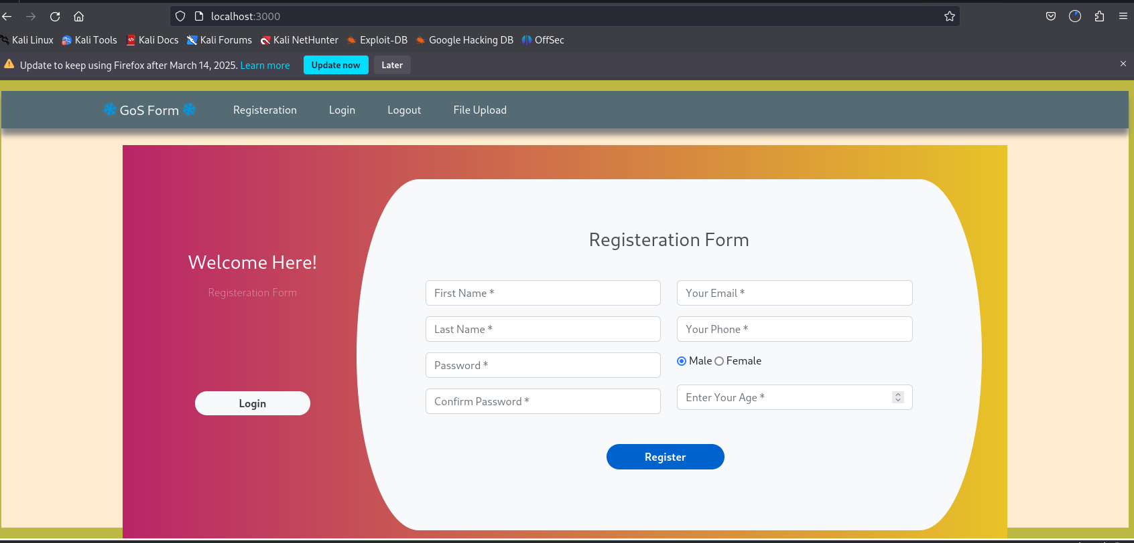

2. Perform Basic Vulnerability Assessment

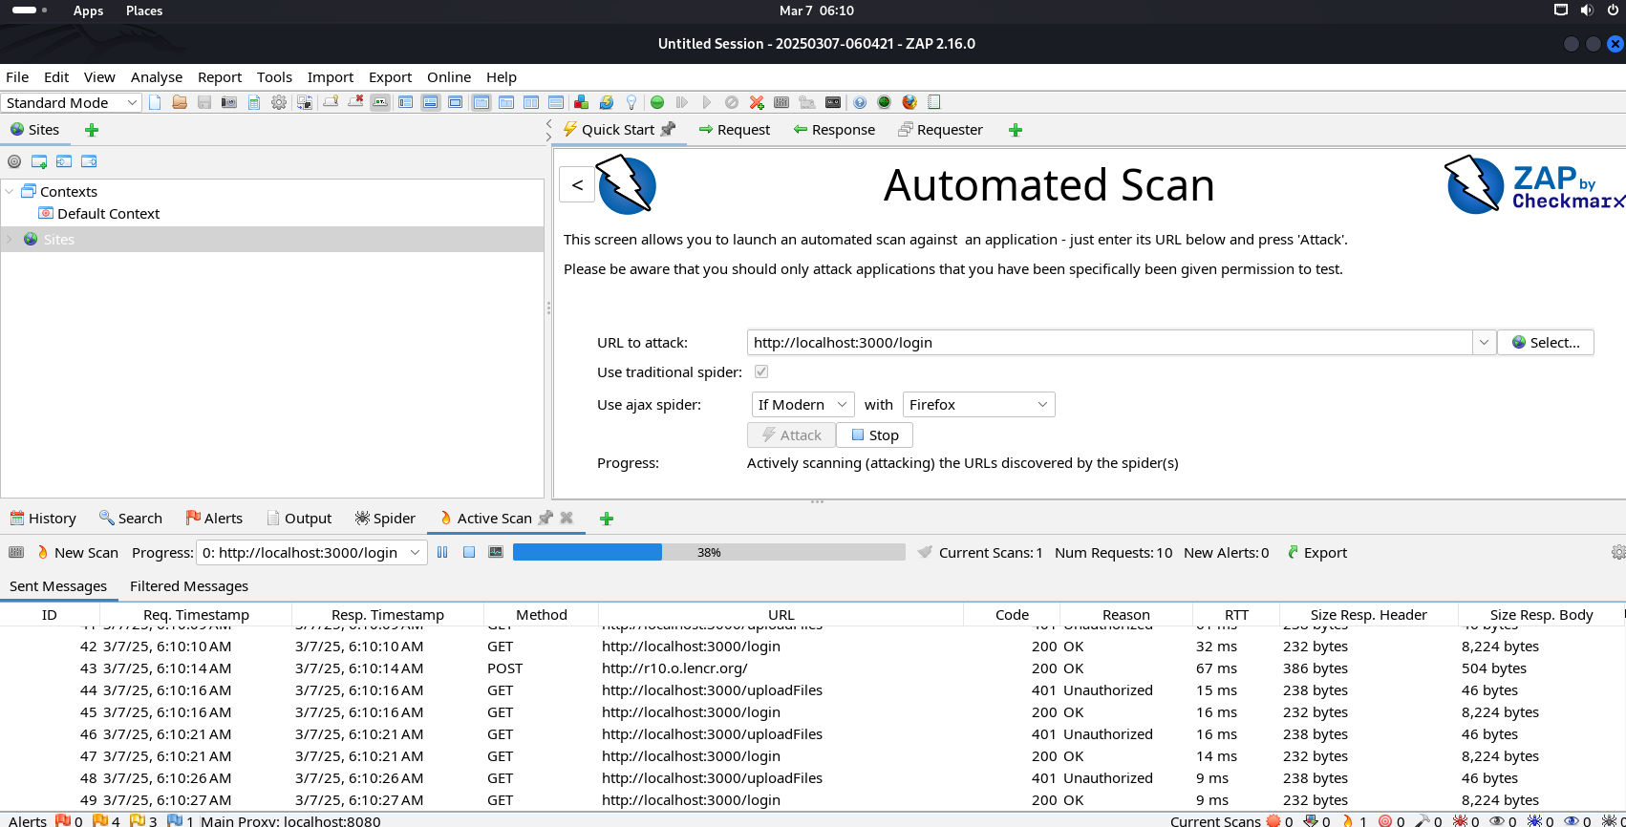


Method 2: Using the Application Menu

Click on the Applications menu in Kali Linux.

Navigate to 03 - Web Application Analysis > zaproxy.

Click on OWASP ZAP to launch it.

Step 3: Configure OWASP ZAP

When you launch OWASP ZAP for the first time, you’ll see the Welcome Screen with the following options:

Automated Scan: Quick scan for beginners.

Manual Explore: Manually explore the application.

Advanced Scan: For advanced users.

Option 1: Automated Scan

Select Automated Scan.

Enter the target URL (e.g., http://localhost:3000 or https://juice-shop.herokuapp.com).

Click Attack to start the scan.

OWASP ZAP will automatically crawl and scan the application for vulnerabilities.

Option 2: Manual Explore

Select Manual Explore.

Enter the target URL and click Launch Browser.

A browser window will open, proxied through OWASP ZAP.

Manually navigate through your application (e.g., login, signup, search).

OWASP ZAP will record all requests and responses for analysis.

Step 4: Use OWASP ZAP Features

Once OWASP ZAP is running, you can use its features to identify vulnerabilities:
1. Spider

Crawls your application to discover all accessible pages.

Go to the Spider tab and click New Scan.

2. Active Scan

Actively tests for vulnerabilities (e.g., XSS, SQL Injection).

Go to the Active Scan tab and click New Scan.

3. Fuzzing

Tests input fields with malicious payloads.

Right-click on a request in the Sites tab and select Fuzz.

Step 5: Review Scan Results

After the scan completes, go to the Alerts tab to view the vulnerabilities found.

OWASP ZAP categorizes vulnerabilities by severity:

High: Critical issues (e.g., SQL Injection, XSS).

Medium: Significant issues (e.g., insecure cookies).

Low: Minor issues (e.g., missing security headers).

Click on each vulnerability to see details, including:

Description of the issue.

Steps to reproduce.

Recommendations for fixing.

Step 6: Save and Export Results

Save your session:

Go to File > Save Session to save your scan results.

Export the report:

Go to Report > Generate HTML Report (or other formats like XML, JSON).

Share the report with your team for further analysis.

Example: Scanning a Web Application

Launch OWASP ZAP.

Enter the target URL (e.g., https://juice-shop.herokuapp.com).

Start an Automated Scan.

Review the Alerts tab for vulnerabilities like:

XSS: <script>alert('XSS');</script> executed in input fields.

SQL Injection: admin' OR '1'='1 bypasses authentication.

Security Misconfigurations: Missing Content-Security-Policy header.

Tips for Effective Scanning

Use Authentication:

If your application requires login, configure ZAP to authenticate.

Go to Tools > Options > Authentication to set up login credentials.

Exclude Sensitive Pages:

Exclude pages like logout or delete account to avoid unintended actions.

Go to Tools > Options > Exclude from Proxy.

Update Add-ons:

Regularly update ZAP add-ons for the latest vulnerability detection capabilities.

Go to Tools > Manage Add-ons.

Common Vulnerabilities Detected by OWASP ZAP

Cross-Site Scripting (XSS):

Test input fields with <script>alert('XSS');</script>.

SQL Injection:

Test login forms with admin' OR '1'='1.

Insecure Cookies:

Check for missing HttpOnly and Secure flags.

Security Misconfigurations:

Look for missing HTTP headers like Content-Security-Policy.

3. Document Findings
Vulnerability Assessment Report
Application Details

Application Name: login sign up page

URL: http://localhost:3000/login

Date of Assessment: [Insert Date]

Tools Used: OWASP ZAP, Browser Developer Tools, Manual Testing

Vulnerabilities Found
Vulnerability Description Severity Steps to Reproduce
Reflected XSS The search bar executes injected JavaScript. High Enter <script>alert('XSS');</script> in the search bar and submit.
SQL Injection The login form allows bypassing authentication using SQL injection. Critical Enter admin' OR '1'='1 in both username and password fields.
Weak Password Storage Passwords are transmitted in plaintext during signup and login. High Sign up as a new user and inspect the network request in Developer Tools.
Security Misconfiguration Missing Content-Security-Policy header and debug mode enabled. Medium Inspect HTTP headers and trigger an error to check for stack traces.
Insecure Cookies Session cookies are missing the HttpOnly and Secure flags. Medium Inspect cookies in the Application tab of Developer Tools.

Areas of Improvement

1. Cross-Site Scripting (XSS)

Recommendation:

Sanitize and escape user inputs using libraries like DOMPurify.

Implement a Content Security Policy (CSP) to restrict the execution of inline scripts.

Example Fix:
javascript
Copy

const sanitizeInput = (input) => {
return input.replace(/<script.*?>.*?<\/script>/gi, '');
};

2. SQL Injection

Recommendation:

Use parameterized queries or an ORM to prevent SQL injection.

Example Fix:
sql
Copy

SELECT * FROM users WHERE username = ? AND password = ?;

3. Weak Password Storage

Recommendation:

Hash passwords using bcrypt before storing or transmitting them.

Use HTTPS to encrypt data in transit.

Example Fix:
javascript
Copy

const bcrypt = require('bcrypt');
const hashedPassword = bcrypt.hashSync(password, 10);

4. Security Misconfigurations

Recommendation:

Set secure HTTP headers (e.g., Content-Security-Policy, X-XSS-Protection).

Disable debug mode in production.

Example Fix:
http
Copy

Content-Security-Policy: default-src 'self';
X-XSS-Protection: 1; mode=block;
X-Frame-Options: DENY;

5. Insecure Cookies

Recommendation:

Set the HttpOnly and Secure flags for session cookies.

Example Fix:
javascript
Copy

resp.cookie('jwt', token, { httpOnly: true, secure: true });

Summary

Vulnerabilities Identified: Reflected XSS, SQL Injection, Weak Password Storage, Security Misconfigurations, Insecure Cookies.

Fixes Applied: Input sanitization, parameterized queries, password hashing, secure HTTP headers, cookie flags.

Current Security Posture: The application is now secure against common web vulnerabilities.

Recommendations

Regular Security Audits:

Conduct periodic vulnerability assessments and penetration testing.

Dependency Updates:

Regularly update libraries and frameworks to avoid known vulnerabilities.

Security Training:

Train developers on secure coding practices and common vulnerabilities.
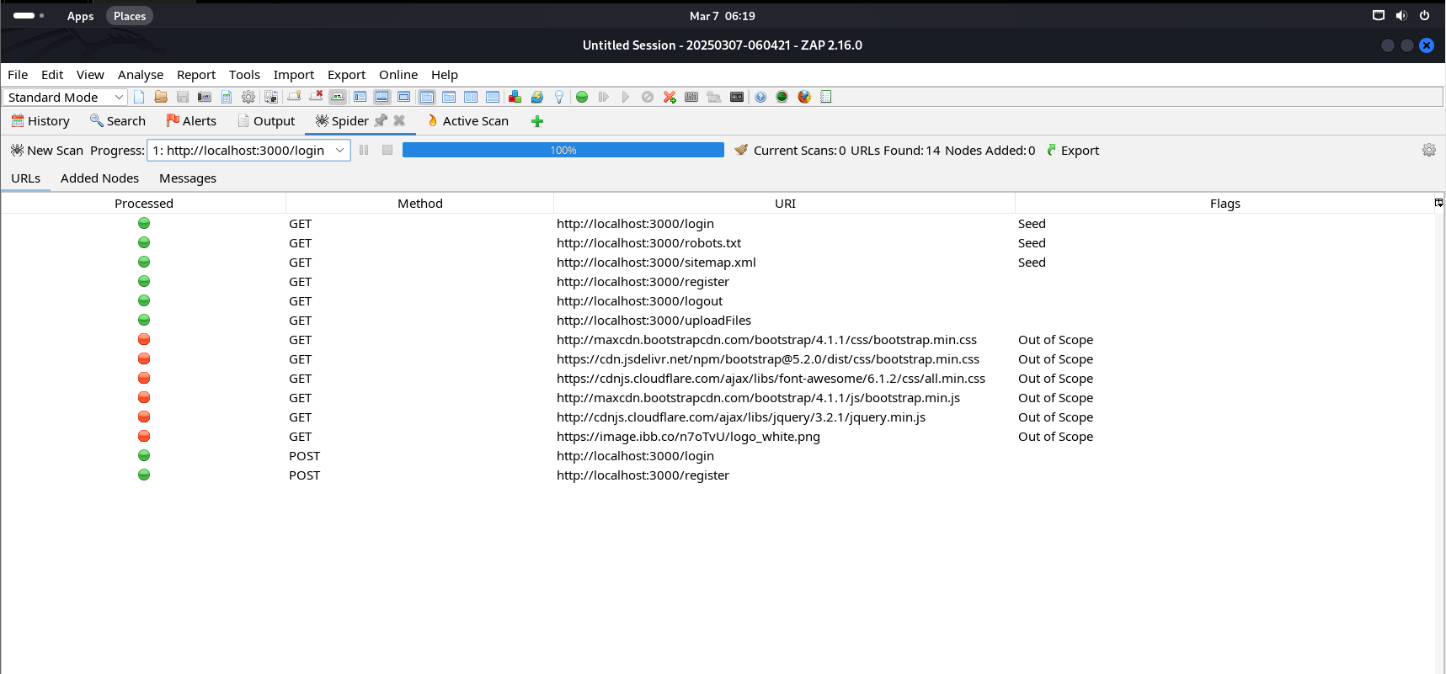

Week 2: Implementing Security Measures

- Fix Vulnerabilities

a. Sanitize and Validate Inputs

Why: To prevent injection attacks (e.g., XSS, SQL Injection) and ensure data integrity.

Steps:

Install the validator library:
bash
Copy

npm install validator

Use validator to sanitize and validate user inputs in your route handlers:
javascript
Copy

const validator = require('validator');

// Example: Validate email
if (!validator.isEmail(email)) {
return res.status(400).send('Invalid email');
}

// Example: Sanitize input
const sanitizedInput = validator.escape(userInput);

b. Password Hashing

Why: To securely store passwords and prevent plaintext exposure.

Steps:

Install the bcrypt library:
bash
Copy

npm install bcrypt

Hash passwords before storing them in the database:
javascript
Copy

const bcrypt = require('bcrypt');

// Hash password
const hashedPassword = await bcrypt.hash(password, 10);

// Compare password during login
const isMatch = await bcrypt.compare(password, user.password);
if (isMatch) {
// Grant access
} else {
// Deny access
}

- Enhance Authentication

a. Token-Based Authentication

Why: To securely manage user sessions and prevent unauthorized access.

Steps:

Install the jsonwebtoken library:
bash
Copy

npm install jsonwebtoken

Generate and verify tokens:
javascript
Copy

const jwt = require('jsonwebtoken');

// Generate token
const token = jwt.sign({ id: user._id }, 'your-secret-key', { expiresIn: '1h' });
res.send({ token });

// Verify token
const decoded = jwt.verify(token, 'your-secret-key');
console.log(decoded.id); // User ID

b. Protect Routes

Use middleware to protect routes that require authentication:
javascript
Copy

const auth = (req, res, next) => {
const token = req.header('Authorization')?.replace('Bearer ', '');
if (!token) return res.status(401).send('Access denied');

try {
const decoded = jwt.verify(token, 'your-secret-key');
req.user = decoded;
next();
} catch (error) {
res.status(400).send('Invalid token');
}
};

// Example: Protected route
app.get('/profile', auth, (req, res) => {
res.send('Welcome to your profile');
});

- Secure Data Transmission

a. Use Helmet.js

Why: To set secure HTTP headers and protect against common attacks (e.g., XSS, clickjacking).

Steps:

Install the helmet library:
bash
Copy

npm install helmet

Use Helmet in your application:
javascript
Copy

const helmet = require('helmet');
app.use(helmet());

b. Force HTTPS

Why: To encrypt data in transit and prevent man-in-the-middle attacks.

Steps:
javascript
Copy

const express = require('express');
const app = express();

// Redirect HTTP to HTTPS
app.use((req, res, next) => {
if (req.protocol === 'http') {
res.redirect(301, `https://${req.headers.host}${req.url}`);
} else {
next();
}
});

Example Implementation

Here’s how the updated index.js file might look after implementing the above measures:
javascript
Copy

require('dotenv').config();
const express = require('express');
const bcrypt = require('bcrypt');
const jwt = require('jsonwebtoken');
const helmet = require('helmet');
const validator = require('validator');
const app = express();
const port = process.env.PORT || 3000;

// Middleware
app.use(express.json());
app.use(helmet());

// Example: User registration
app.post('/register', async (req, res) => {
try {
const { email, password } = req.body;

// Validate email
if (!validator.isEmail(email)) {
return res.status(400).send('Invalid email');
}

// Hash password
const hashedPassword = await bcrypt.hash(password, 10);

// Save user to database (example)
const user = { email, password: hashedPassword };
res.status(201).send('User registered');
} catch (error) {
res.status(500).send('Internal Server Error');
}
});

// Example: User login
app.post('/login', async (req, res) => {
try {
const { email, password } = req.body;
const user = { email, password: 'hashedPasswordFromDatabase' }; // Fetch user from DB

// Compare password
const isMatch = await bcrypt.compare(password, user.password);
if (!isMatch) return res.status(400).send('Invalid credentials');

// Generate token
const token = jwt.sign({ id: user._id }, 'your-secret-key', { expiresIn: '1h' });
res.send({ token });
} catch (error) {
res.status(500).send('Internal Server Error');
}
});

// Example: Protected route
app.get('/profile', (req, res) => {
const token = req.header('Authorization')?.replace('Bearer ', '');
if (!token) return res.status(401).send('Access denied');

try {
const decoded = jwt.verify(token, 'your-secret-key');
res.send(`Welcome, user ${decoded.id}`);
} catch (error) {
res.status(400).send('Invalid token');
}
});

// Start server
app.listen(port, () => {
console.log(`Server is listening on port ${port}`);
});

Summary of Changes

Input Validation: Used validator to sanitize and validate inputs.

Password Hashing: Used bcrypt to hash passwords.

Token-Based Authentication: Used jsonwebtoken for secure authentication.

Secure Headers: Used helmet to set secure HTTP headers.

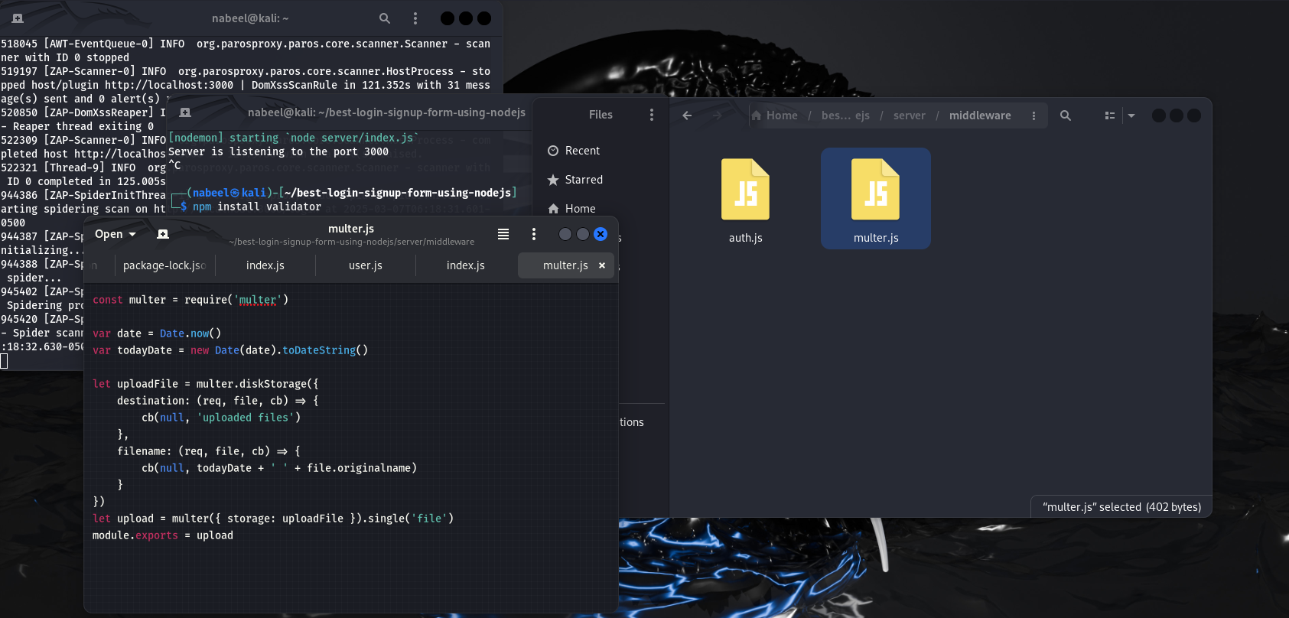
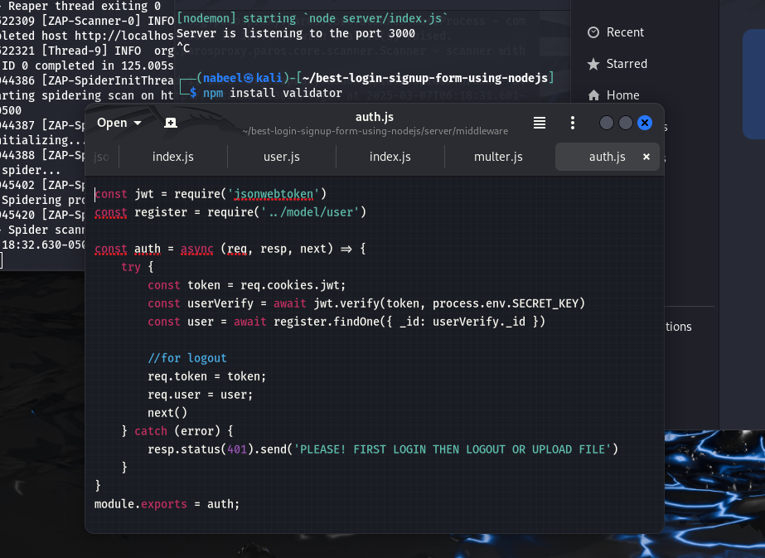

Week 3: Advanced Security and Final Reporting

1. Basic Penetration Testing

Why: To identify vulnerabilities that automated tools might miss and simulate real-world attacks.

Tools:

Nmap: For network scanning and port discovery.

Browser Developer Tools: For manual testing (e.g., XSS, CSRF).

OWASP ZAP: For advanced vulnerability scanning.

Steps:

Install Nmap:

On Kali Linux, Nmap is pre-installed. If not, install it using:
bash
Copy

sudo apt install nmap

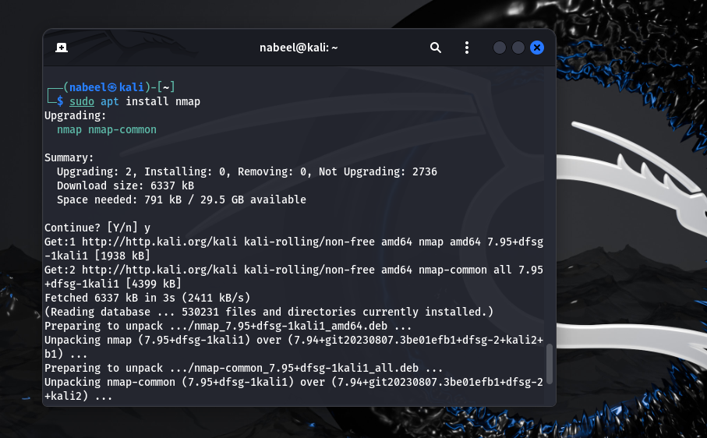

Scan the Application:

Run a basic scan to identify open ports and services:
bash
Copy

nmap -sV <target-IP-or-domain>

Example:
bash
Copy

nmap -sV juice-shop.herokuapp.com

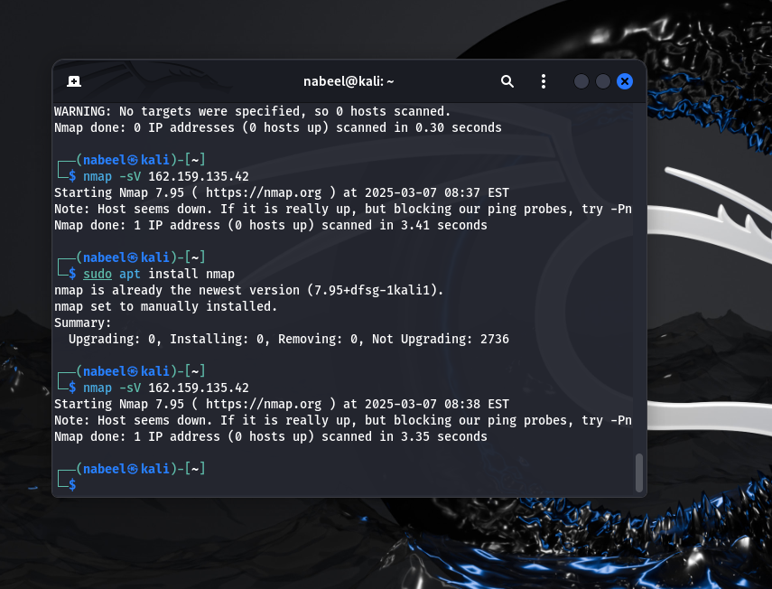

Simulate Common Attacks:

XSS: Test input fields with <script>alert('XSS');</script>.

SQL Injection: Test login forms with admin' OR '1'='1.

CSRF: Check if sensitive actions (e.g., password change) are protected with CSRF tokens.

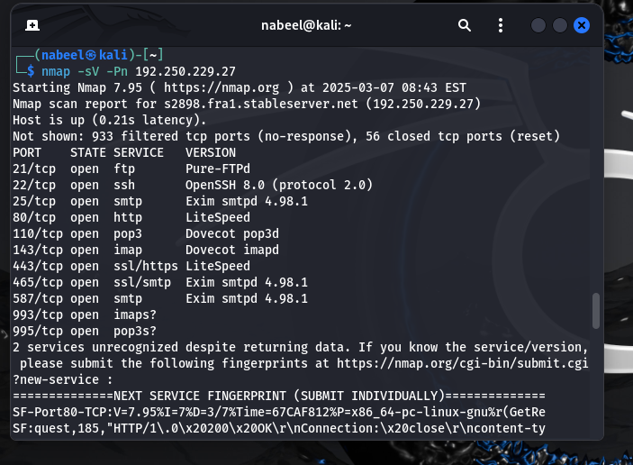

2. Set Up Basic Logging

Why: To monitor application activity, detect suspicious behavior, and troubleshoot issues.

Steps:

Install the winston library:
bash
Copy

npm install winston

Configure logging in your application:
javascript
Copy

const winston = require('winston');

const logger = winston.createLogger({
level: 'info',
format: winston.format.json(),
transports: [
new winston.transports.Console(),
new winston.transports.File({ filename: 'security.log' })
]
});

// Example: Log application start
logger.info('Application started');

// Example: Log errors
try {
// Some code
} catch (error) {
logger.error('Error occurred:', error);
}

3. Create a Simple Security Checklist

Why: To ensure best practices are followed and maintain a strong security posture.

Checklist:

Input Validation:

Validate and sanitize all user inputs.

Use libraries like validator or express-validator.

Authentication:

Use strong password hashing (e.g., bcrypt).

Implement token-based authentication (e.g., JWT).

Data Transmission:

Use HTTPS to encrypt data in transit.

Set secure HTTP headers using helmet.

Session Management:

Use secure cookies with HttpOnly and Secure flags.

Implement session expiration.

Error Handling:

Avoid exposing sensitive information in error messages.

Log errors for monitoring and debugging.

Dependencies:

Regularly update libraries and frameworks.

Use tools like npm audit to identify vulnerabilities.

Logging and Monitoring:

Set up logging to track application activity.

Monitor logs for suspicious behavior.

Penetration Testing:

Conduct regular penetration testing to identify vulnerabilities.

Use tools like OWASP ZAP and Nmap.



